Spring-core:
- Introduction
- What is dependency Injection and Types of DI
- How to configure DI in Spring
  - XML configuration
  - Java configuration
  - Annotation
- Examples
- Scope -singleton, prototype
- Load the properties file
- Profiles – dev, test, uat, production
- How to apply spring core in web applications
- Spring bean Aware interfaces
- Spring bean life cycle
Introduction:
What is spring and why introduced into market?
- The mail goal of spring framework is to make J2EE application development was easier.
J2EE: Servlet, JSP, RMI, EJB… etc
Drawbacks of J2EE applications:
- Tightly coupling – Applications should extend Servlets, EJB etc…
- Heavy weight – Application startup will take more extra processing
- Bioler plate code – common code is getting repeated in multiple places to do some activity
- Cross cutting concerns –– it doesn’t support security, transactions inbuilt, need to implement manually
Spring Advantages:
- Make application development easier
- Light weight
- Modularity: core, mvc, batch, transaction, security, boot, webmvc, dao, aop etc…
- POJO development: Spring doesn’t force your application to extend or implement any string framework classes.
- Popular: loosely coupled and Unit Test code
Why Spring is sustaining in market?
Spring comes with many APIs to work with any of the technologies like Mongo DB, KAFKA etc..

Spring core:
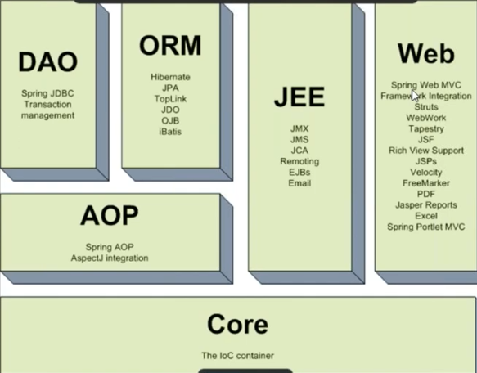

- Spring core is the base module for all of the other module.
- It is used to manage the object dependencies.
- In project development there can be multiple classes, if we want to communicate one object with another object then we should communicate with interfaces.
- Using this module spring will create the required objects and supply to the application
i.e., developer no need to create any object in application development
- SOLID principle:
  - Every class should have one responsibility
  - Every project would have multiple classes if we follow SRP
  - Every class developer should create the object
  - When application is running these objects should interact with another object
- Dependency: it is an object required by another object to carryout the functionality
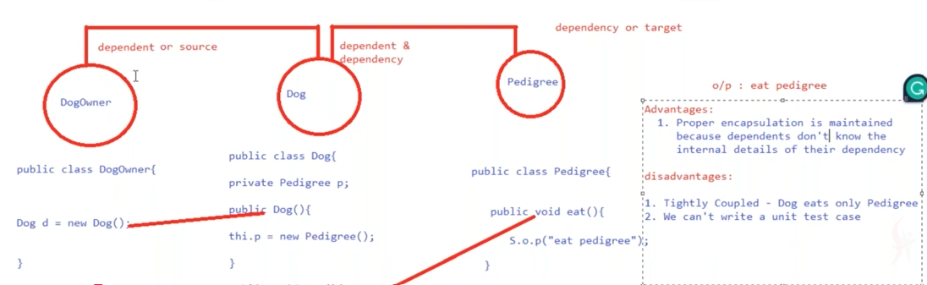

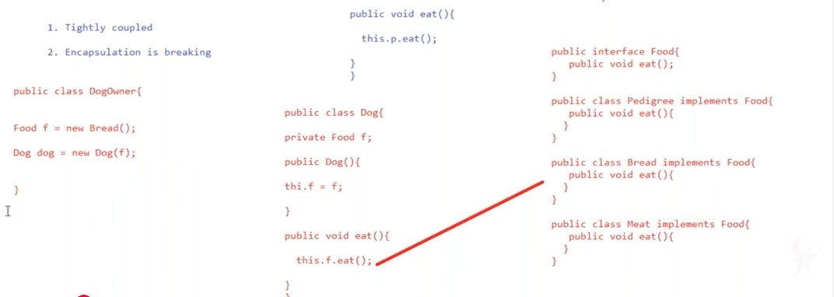
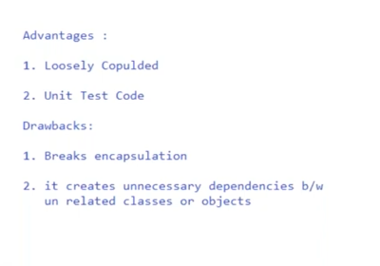
Dependency Injection:
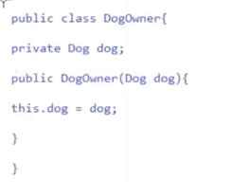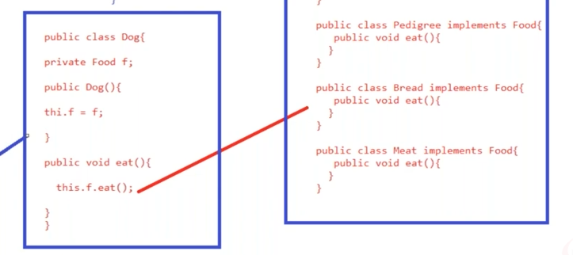
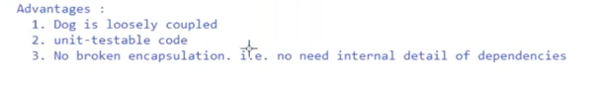
- How Spring will provide the objects?
- How to get the object from Spring?

To implement spring core we should follow 3 steps:
- Configuration
- Dependency Injector
- Use the beans or get the beans

- What object to be created: DogOwner, Dog, Food, Pedigree, Bread, Meat etc
- How to create them
- What dependencies to inject

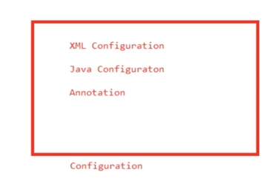
Spring-config.xml:
<beans>
- Create a pedigree object using the default constructor
<bean id =”pedigree ” class=”com.seravana.Pedigree”>
</bean>

- Create Dog object & Inject into Pedigree Object
<bean id=”dog” class=com.seravana.Dog”>
<constructor-arg ref=”pedigree”>
</bean>
- Create DogOwner Object and inject Dog Object which is created in step2
<bean id=”dogowner” class=com.seravana.DogOwner”>
<constructor-arg ref=”dog”>
</bean>
</beans>
What happens when we create BeanFactory Object?
BeanFactory factory= new XMLBeanFactory(new ClasspathResource(“xml file”));
- It will read the xml file and validate, if the xml is valid then
- XMLBeanFactory creates inmemory logical memory partition inside JVM
- Loads the spring bean configuration file and place metadata in the logical memory
- The logical memory partition created by XMLBeanFactory is called IOC container and returns
the reference of IOC container as BeanFactory
- DogOwner dogowner=beanFactory.getBean(“dogowner”);
  - beanFactory goes to IOC container (logical memory) and searches for bean with given id(“dog owner”), if the dogowner not found then it will throws exception and exit the application
  - Once the bean definition is found then it will read the corresponding class name and
Load the class into JVM memory and instantiate the object of the class.
IOC principle: collaboration of objects and managing the life cycle object is called IOC collaboration -managing dependencies.
Manage the dependencies:
- Dependency lookup: if the developer write the code to manually goto container and get the object is called “dependency lookup”
- Dependency injection: automatically get the dependencies objects
NOTE: container will store the objects references but objects will be stored in jvm
Container is just like hashmap
Key =bean id and value =class name

- Spring internally use reflections to create the objects inside the JVM.

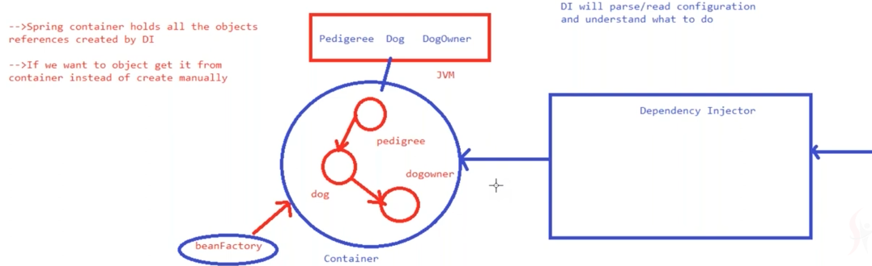
Types of String Container:
- BeanFactory
- ApplicationContext
Dependency Injection: it is the process of getting the objects from spring container, instead of created by the developers.
- Setter Injection: The dependent object is injected into targeted object via setter methods.
Class B
{
}
Class A
{
B b;
Public void setB(B b)
{
this.b=b;
}
}
- Constructor Injection: Dependent object is injected into targeted object via constructor
Class A
{
B b;
A(B b)
{
this.b=b;
}
}

Use case: Customer card payment
Write pen Ink
